Magic Words

after as if even though however provided that
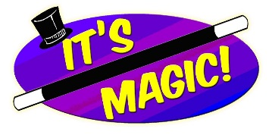
since then until while yet till when although before because for if just as once so still though unless where whenever

Magic Words

after as if even though however provided that
since then until while yet till when although before because for if just as once so still though unless where whenever

